**Battle of the neighborhoods: Tattoo Parlor Location**

**Introduction**

The problem that I am trying to solve involves a trio of tattoo artists who became close during their tenure at school and have come together close to graduation to decide where they should open a Tattoo Parlor of their own in either San Francisco, NYC or Toronto. They chose these main cities because each of them hails from one of these cities and so moving there would not be too much of a compromise since they would be in the home city of one of them. However, these individuals need help in identifying where they should move. The main predictor for their moving is potential for a new market, initially dependent on competition. As a result, they hope to see if there are potential neighborhoods in each city where they could set up shop.

Halfway through the project, two of the artists get married and one of the spouses relocates from Toronto, making Toronto an invalid option. As a result, the choices end up becoming San Francisco and New York City. Because there are only two options at the end, the artists need another way to evaluate where they should move, and they task us with adding crime incidence data as an added factor. As a result, the project initially involved Toronto, but the crime analysis is directed only at SF and NYC.

**Data**

I’ll be using six datasets:

1. <https://en.wikipedia.org/wiki/List_of_postal_codes_of_Canada:_M>.- . I will use this data to source the latitudes and longitudes of different neighborhoods in Toronto.

2. <https://cocl.us/new_york_dataset> - I will be using this dataset to get neighborhood data for New York City.

3. Foursquare API- The API will be accessed using my client id & client secret. The API is instrumental in getting location data for the tattoo parlors. Due to computational capabilities, each search query will have a limit of 500. The impression is that there won’t be more than 500 tattoo parlors in a city, although that could be wrong but that’s the key assumption in this project. The data will be used to generate location maps to show the distribution of tattoo parlors in different neighborhoods in the three cities.

4. <https://cocl.us/sanfran_crime_dataset> - This dataset contains detailed accounts of criminal incidences in different neighborhoods in San Francisco, I will be using this data to come up with criminal incidences per neighborhood.

5. <https://opendata.cityofnewyork.us/> - This dataset contains detailed accounts of criminal incidences in different neighborhoods in New York City, I will be using this data to come up with criminal incidences per neighborhood.

6. <https://cocl.us/sanfran_geojson> - This dataset contains geographical data on San Francisco. It is a json file, with features and properties ranging from the boroughs, districts and neighborhoods, to the streets at the micro level.

**Methodology**

This section will be split into groups, each featuring the wrangling and processing that was done on each dataset.

1. List of Postal Codes In Canada: M dataset. This dataset was extracted using the web scraping capabilities of Beautiful Soup. The headings are renamed to make it easier to identify the feature of each column. An initial examination of the table shows that there is some missing data.

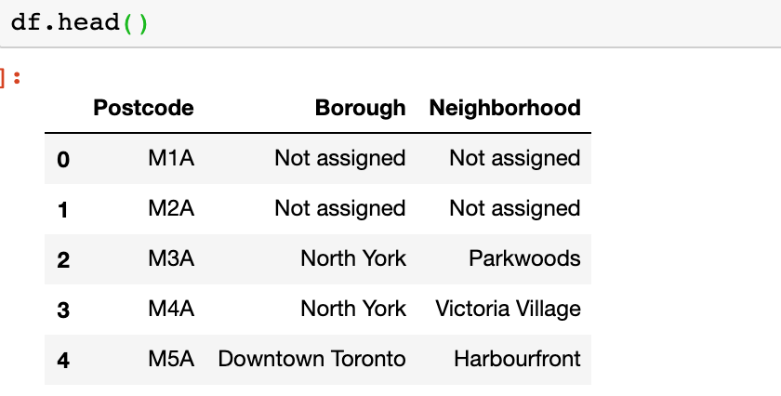

This missing data is addressed by dropping it since it’s a relatively small dataset, whose results won’t be gravely changed by dropping the null values. The neighborhood column with missing information is filled with corresponding Borough. The boroughs are then grouped by postal code, and each neighborhood grouped by Borough. Because of the method we chose to wrangle the data, it is clear that the M1A postcode has neither a corresponding borough nor neighborhood.

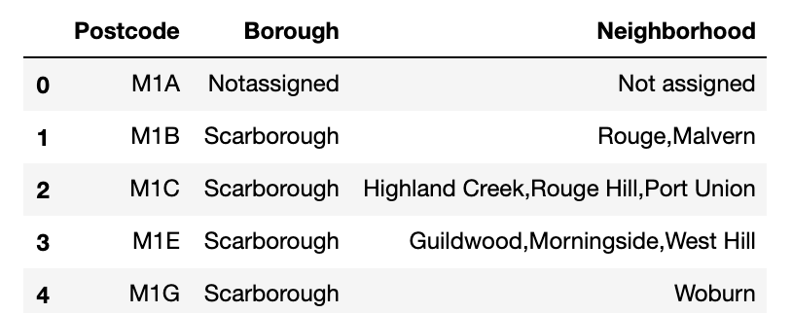

2. The second dataset is a json file. Since there are a lot of entities to the dataset, we have to isolate the data we need. This data is located in ‘features’. The features are interrogated to have the name of neighborhood, borough, latitude and longitude data. This generates a table that can then be used for further data analysis.

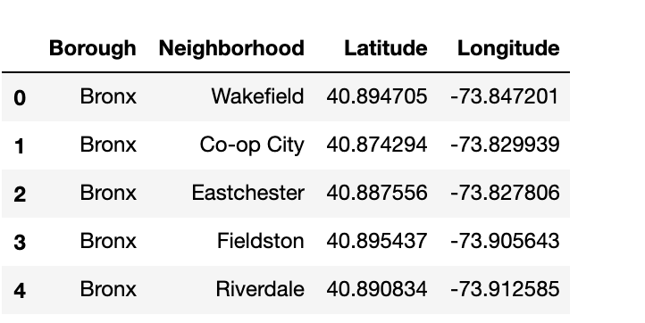

3. Foursquare API- The API is accessed using the client ID and client secret. For each of the cities, an address variable is defined which details what city we are looking for. The geolocator is accessed using the Nominatim library, which contains the user agent. Once the location is produced, we orchestrate a search query, and define our url. The url produces results that are in a json table. Since we are interested in the venues, we will isolate the venues from the results table. Then we filter columns and form a data frame with the filtered columns. After that we use a function to get names and categories of different venues in a query. Then in order to get the categories added to the originally created data frame, we create a new column with the new function. That will generate a data frame as indicated below for Toronto. Similar data frames are produced for both New York and San Francisco as well. 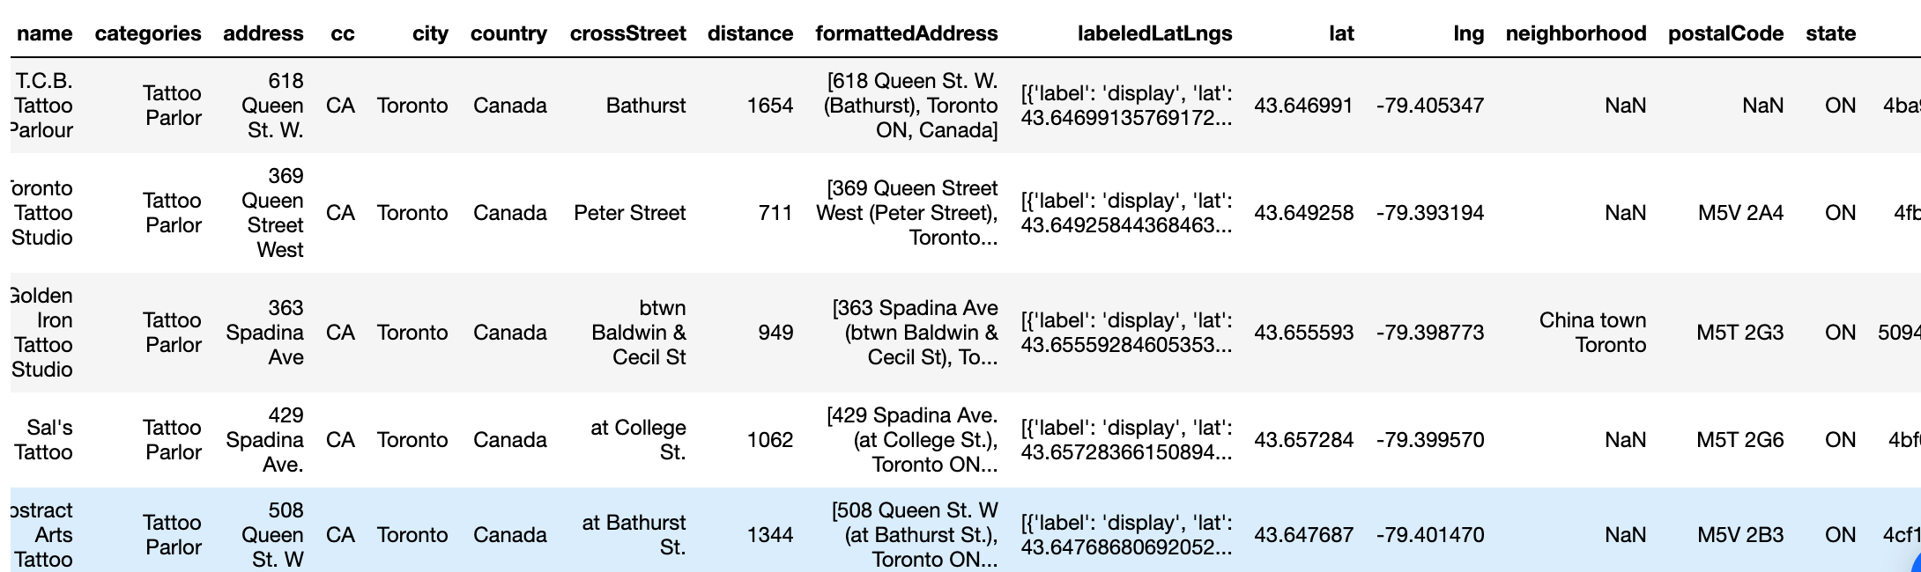

We then clean up the data frame so that we only have four columns remaining. 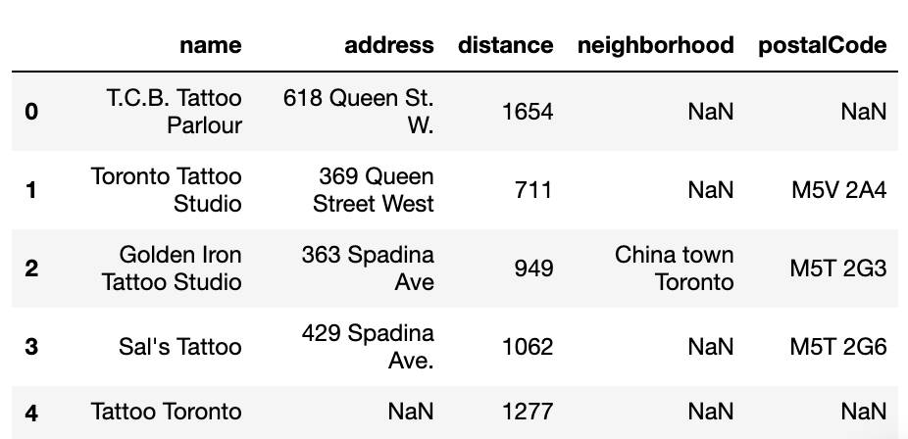

4. The San Francisco crime dataset is a csv. San Franscisco data is opened as a pandas dataframe, and the dataframe is reduced to two columns with the pertinent data-'IncidntNum' and 'PdDistrict'. The fields are renamed 'Count' and 'Neighborhood' respectively. For the count to work, we have to group the incident numbers by the neighborhoods in which they occurred. **For ease of computation, the limit is set for the first 1000 cases only.**

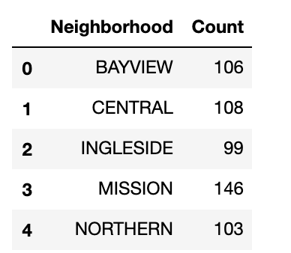

5. The fifth dataset is from NYC open data. For uniformity with the data available for San Francisco-which is only for the year 2016, the NYC data was filtered to only include 2016 data as well. It was downloaded as a csv file and uploaded to the IDE for wrangling. For ease of computation, the limit is set for the first 1000 cases only. A new data frame is defined that only contains five columns. The data is also grouped by neighborhood as for San Francisco.

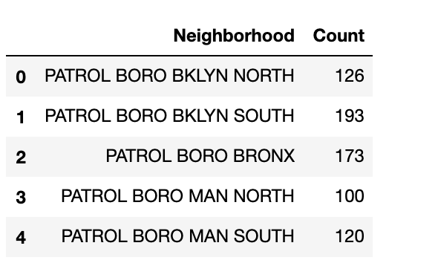

6. The San Francisco geojson dataset did not require any wrangling or analysis, since it served only one purpose-it was used for data input for generating the choropleth map.

**Results**

The good news for our clients is that Toronto is out of the picture, because it would have been automatically removed from the options anyways because there are a lot more tattoo parlors spread widely in Toronto. Trying to find a neighborhood to launch a business in Toronto would have been met with fierce competition.

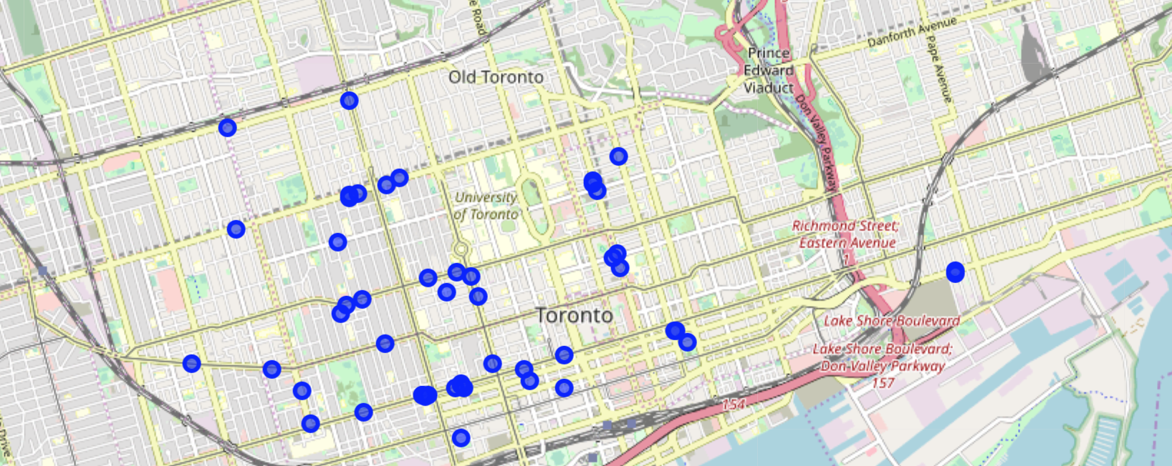

**However, for NYC and San Francisco, the distributions are as follows:**

**San Francisco:**

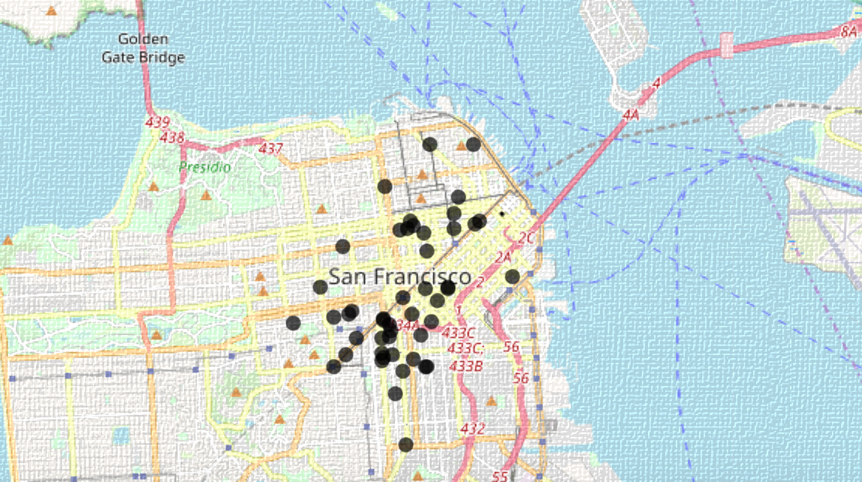

**New York City Map:**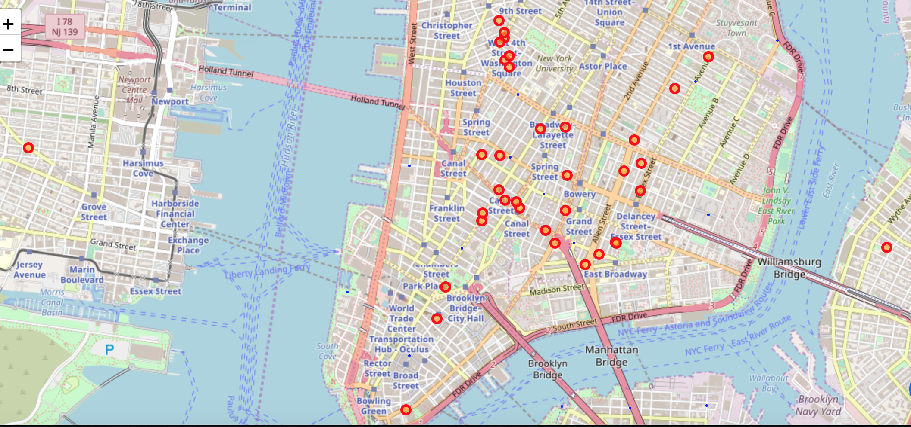

**When we factor in crime incidence, the results are as follows:**

**San Francisco Map:**

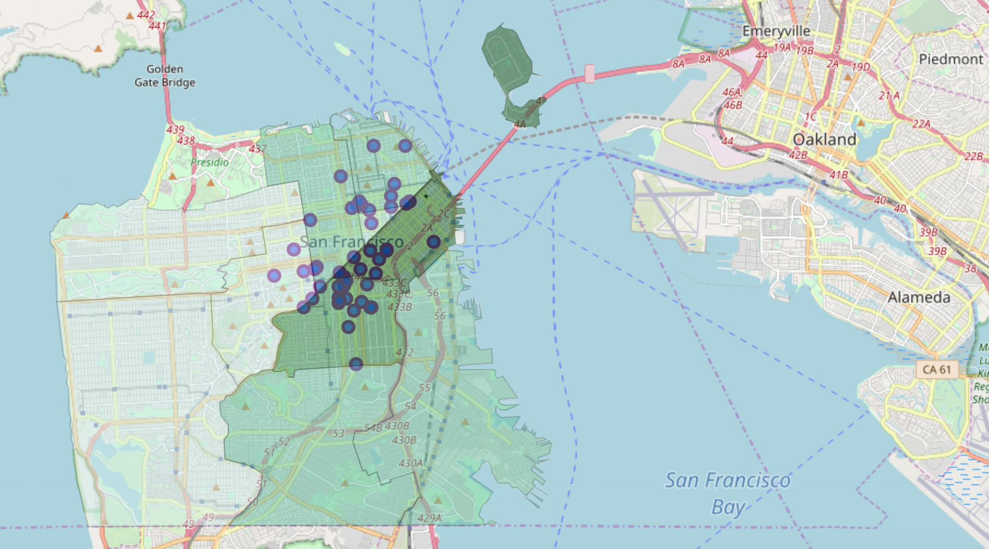

**New York City Map:**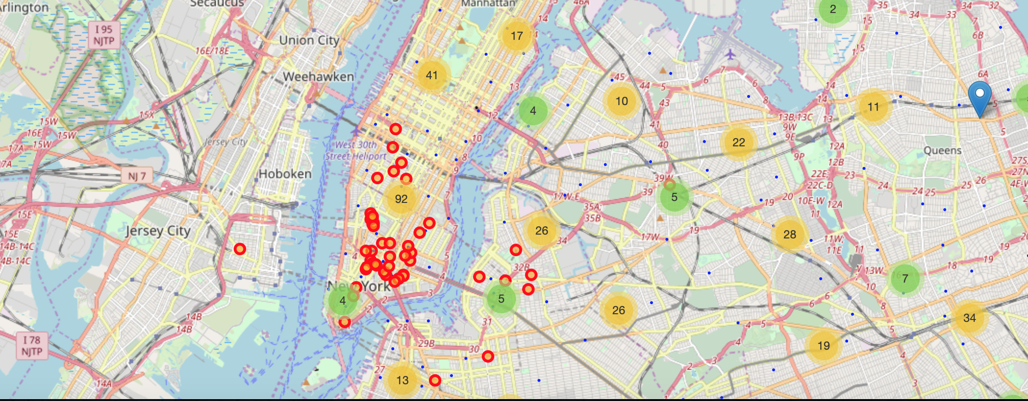

**San Francisco Table Summary**

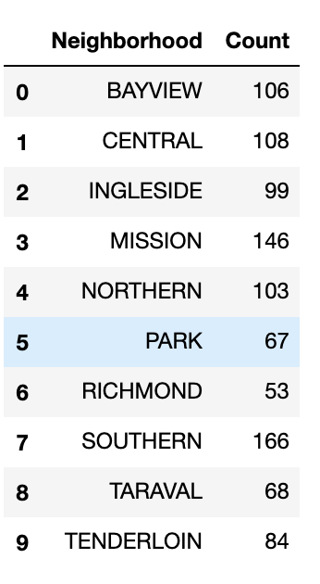

**New York City Table Summary**

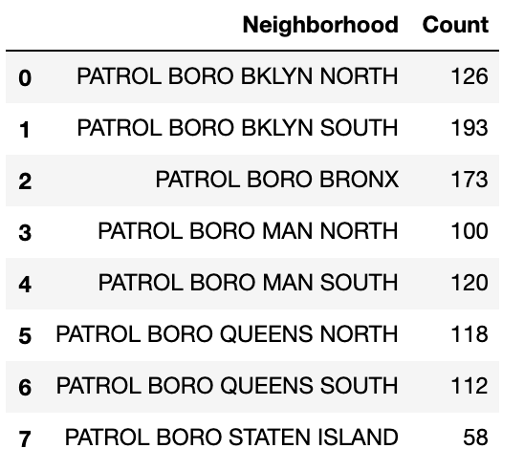

**Discussion**

It is apparent from the data that most of the tattoo parlors in New York City are in Manhattan. That is to be expected due to the centrality of the island. There are a lot of businesses there as well as a lot of people. If the tattoo artists are going to bring incentives that can tackle the pre-existing competition, then Manhattan would be the place for them to set up shop. However, there is also a particularly high incidence of crime in that area, accounting for about 20% of the crime incidence in the city. As a result, there is an associated risk of both stiff competition and crime incidence hampering their chances at a successful launch in Manhattan. If they were to only consider crime, then they would be better served by opening up an establishment on Staten Island, since it had the lowest incidence of crime. Other than that, the artists have a greater chance of launching a successful parlor in any of the other boroughs of New York except Manhattan due to fewer competitors.

For San Francisco, if they wanted to move to areas with low crime, then they would have the most success in Park, Taraval and Richmond. They would also be met with less competition there because there are fewer tattoo parlors in those neighborhoods. Other areas that they could infiltrate include Bayview, which has almost no tattoo parlors, and would be a promising market for clientele. However, other factors may stand in the way of them being able to set up a business there such as real estate pricing, and other local laws. Places like Ingleside and Merced would also be good areas to launch a business for lack of competition as well. Most of the tattoo parlors are located in the Downtown, Mission District and South of Market areas, and those would be the areas with higher crime incidence as well, and thus there would be reasonable places to avoid for our aspiring artists.

However, due to the limitations imposed on the datasets, this information is not reliable enough to warrant a hard and fast decision, but it is a starting point, one on which preliminary decisions can be made.

**Conclusion:**

The artists have a hard decision to make. Both cities are metropolitan and encompass a good level of clientele. Each city has areas where there is a conglomeration of tattoo parlors, and some research may need to be done to determine why that is so before a decision is made. However, making the decision based on distribution of tattoo parlors as well as the crime rate, **I’d recommend that the tattoo artists set up shop in San Francisco, particularly in the Port, Bayview and/or Ingleside neighborhoods.**